**Comsats University Islamabad, Lahore Campus**

**Course Title: Object Oriented Programming**

**Assignment #2**

**Submitted by: Attika Hussain (SP24-BSE-017)**

**Section: A**

**Submitted to: Sir Shahid Bhatti**

**Assigned Date: 22nd November 2024**

**Submission Date: 23rd November 2024**

Assignment 2:

Design a graphic User interface for a student admission form.

* Firstly will design a frame for the form. Assign a suitable width and height and set default close function.
* Suitable Padding is added to align the page and make the page look presentable.

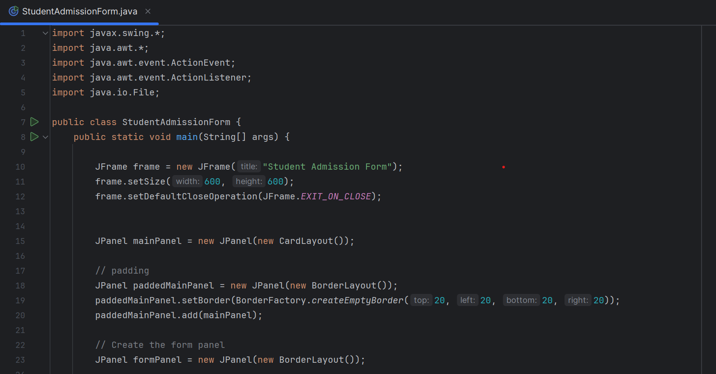

* Add image to the form using the following code
* Then scale it properly

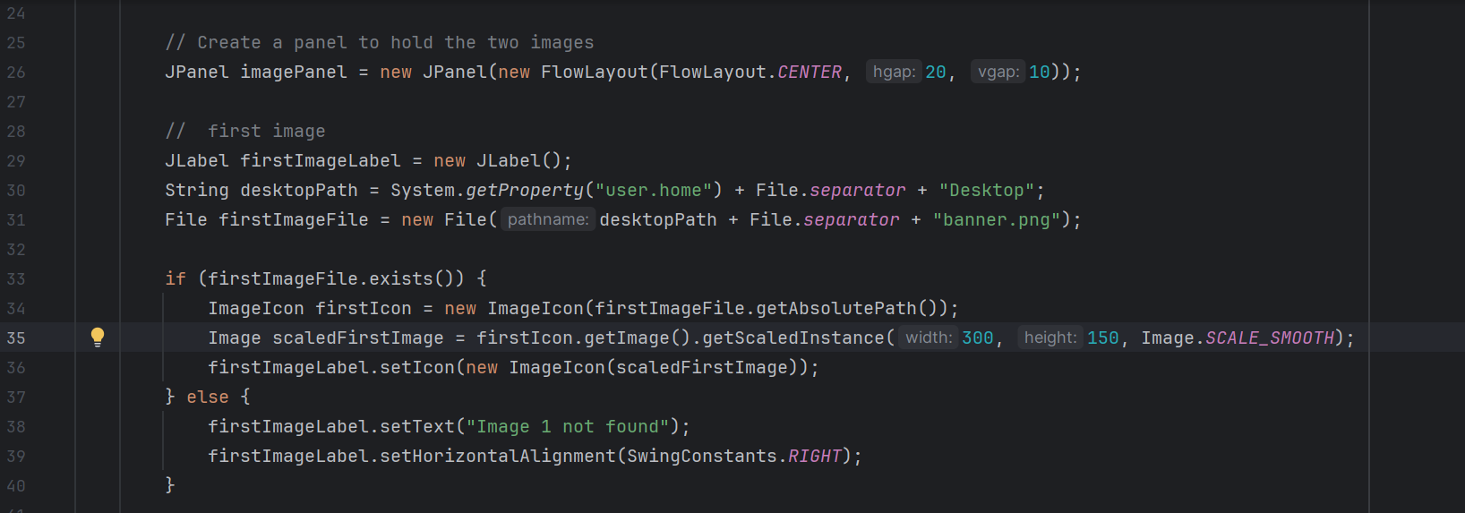

* Repeat the same code to add another image

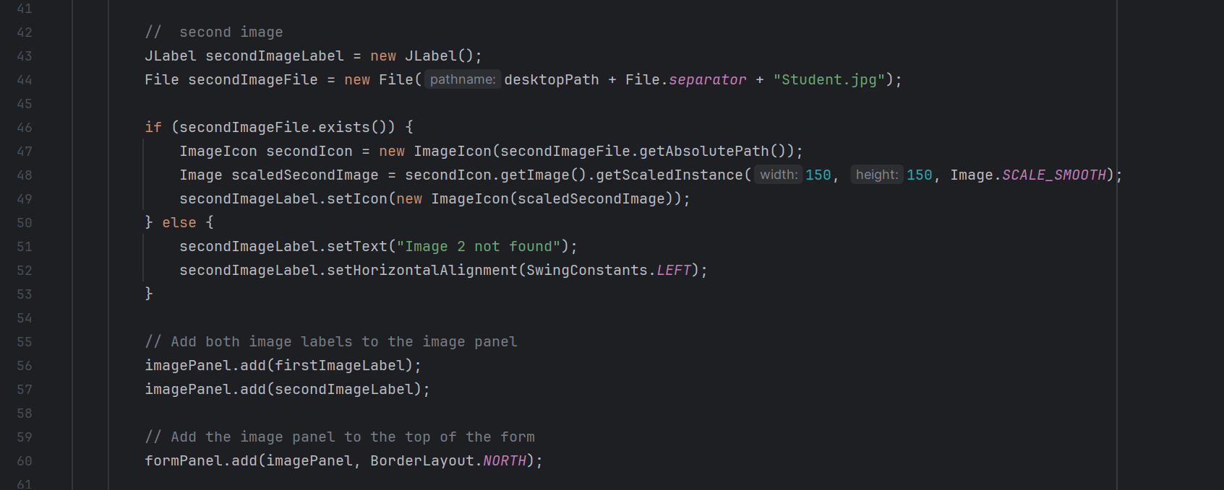

* Add fields like name, father’s name, gender, email, city and address as features of the form.

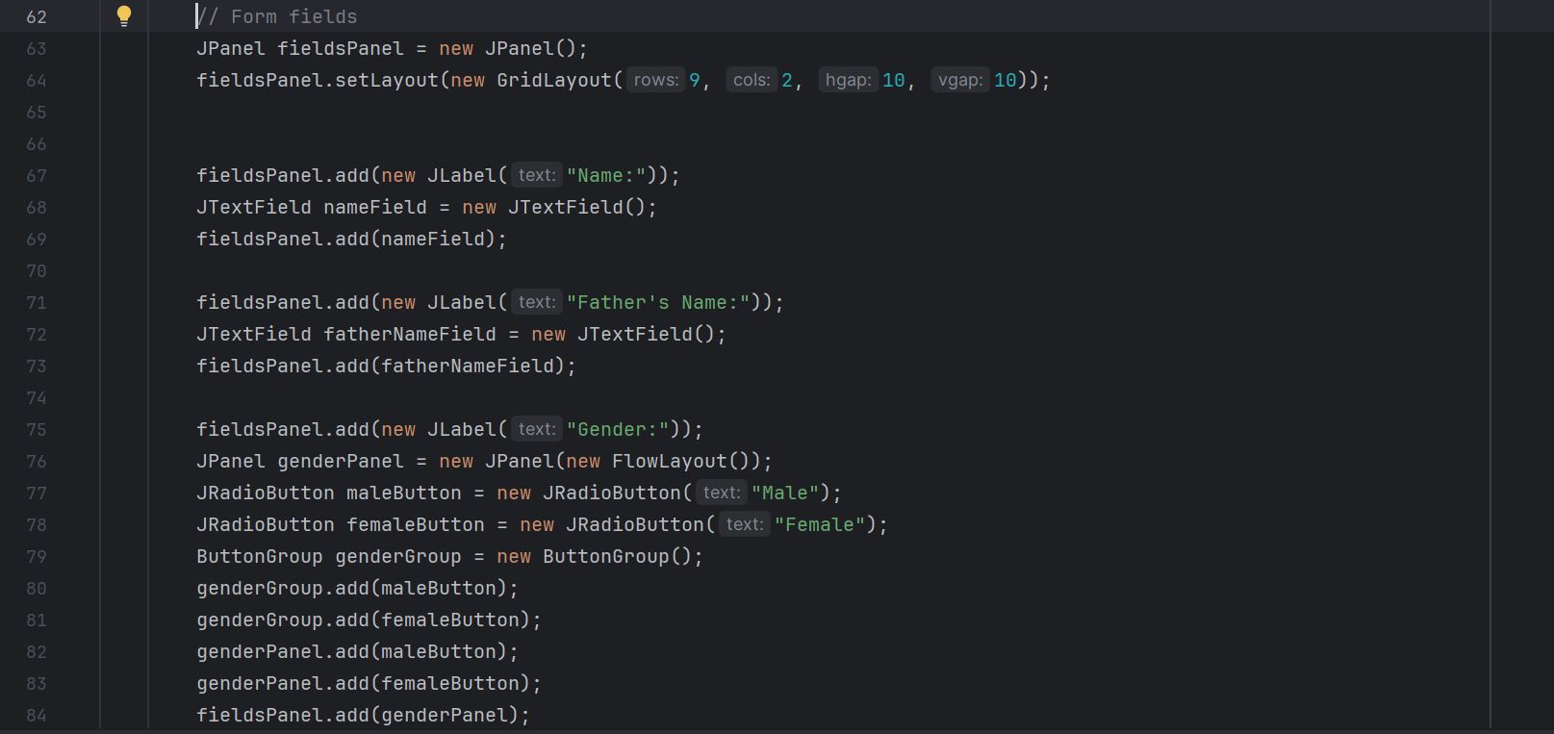

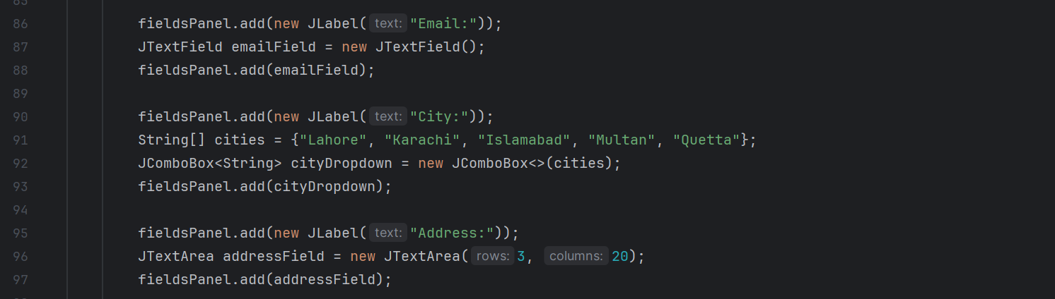

* Add buttons

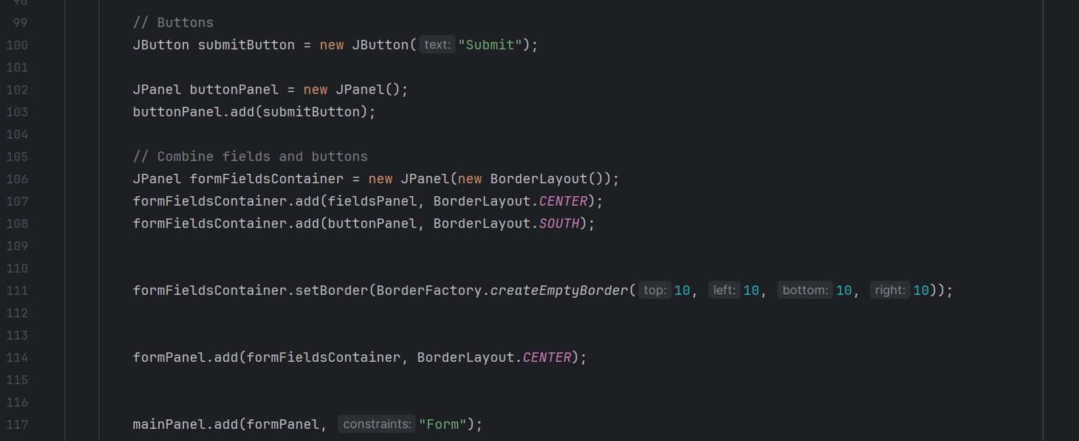

* Add code to display the message of “Form submitted successfully” on the next screen.

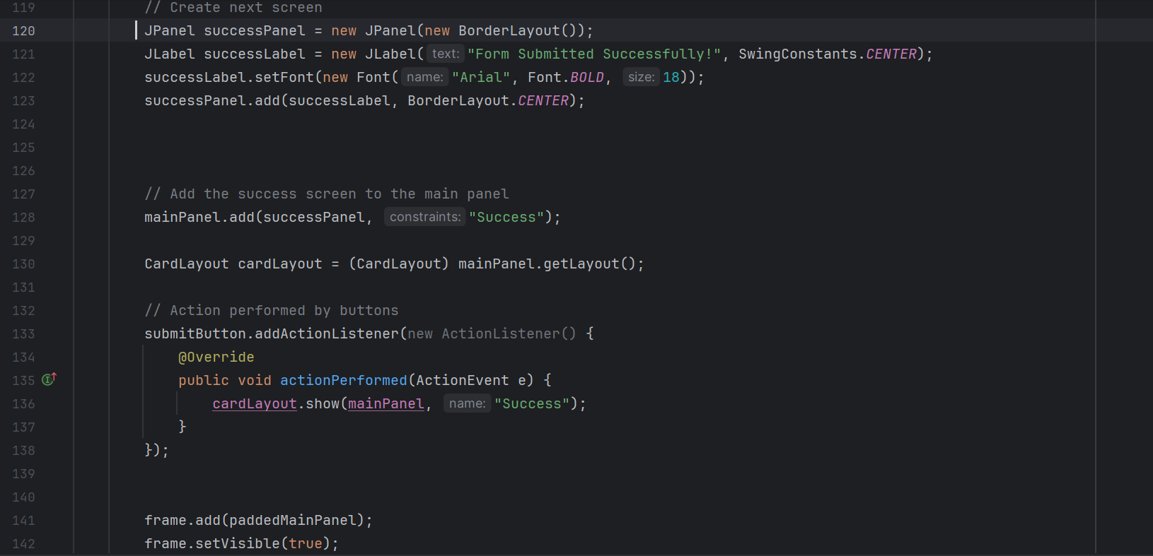

* The display of the form is shown below.

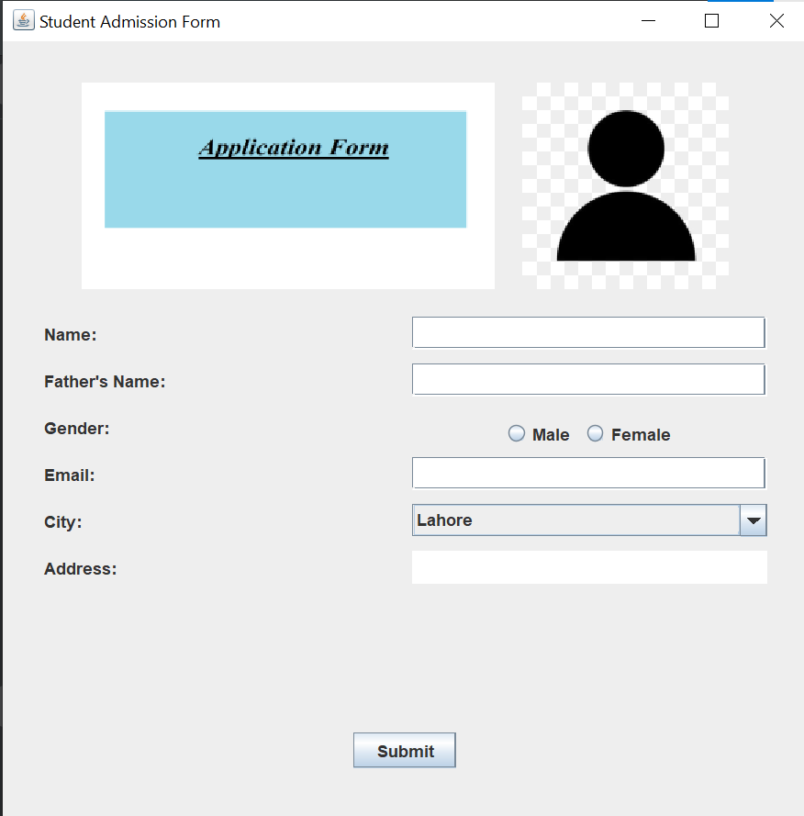

* Add Details

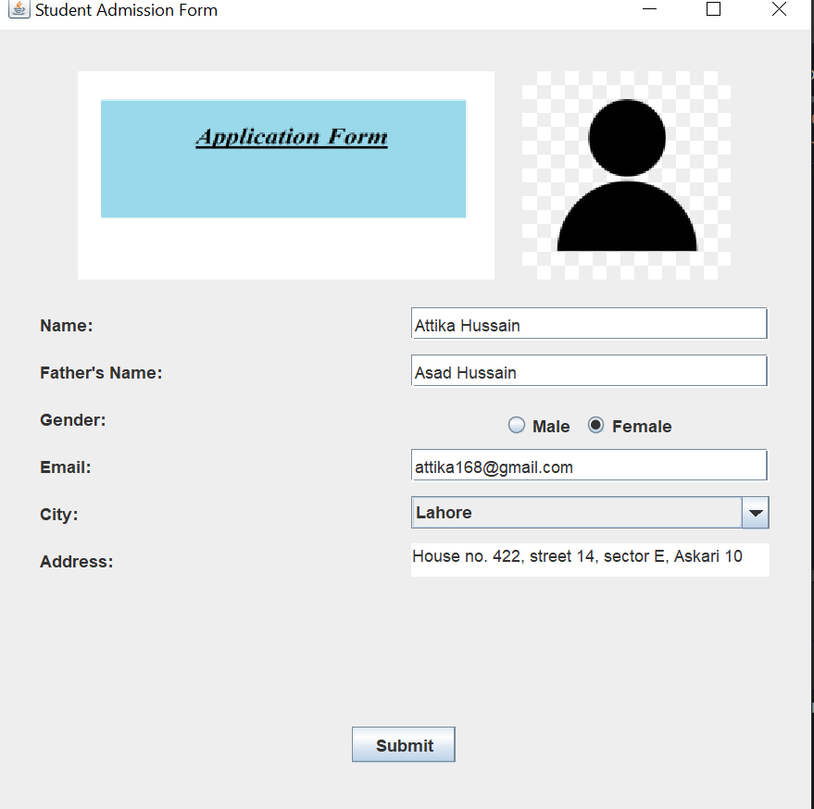

* After adding the details click the submit button to see the message “Form Submitted Successfully” on the next screen.

